**Setup with Visual Studio Code**

There are Prettier plugins for many different editors available. Here I'll show the setup in [Visual Studio Code](https://code.visualstudio.com/).

**1. Install the Prettier VS Code plugin**

Open the Command Palette (under the View submenu, or using Cmd+Shift+P on Mac and Ctrl+Shift+P on Windows). Then select "Extensions: Install Extensions".

Search for "Prettier", click "Install", and then "Reload" once the installation is complete.

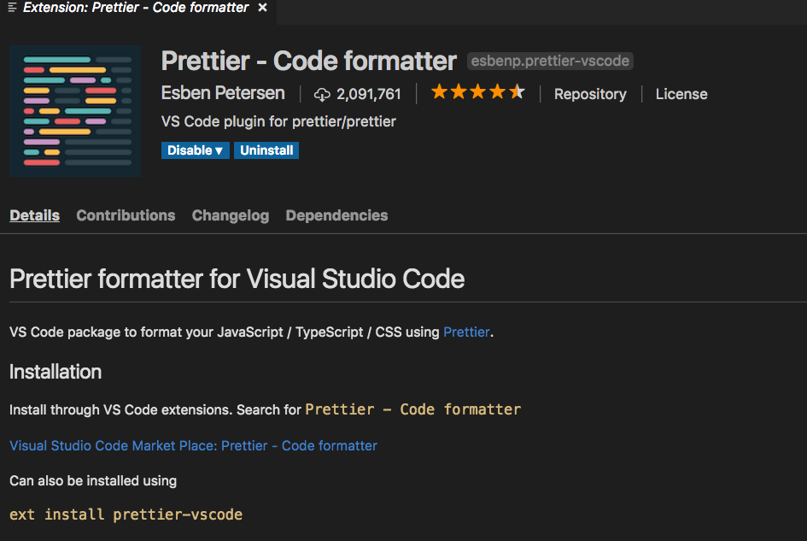

Open the settings of VScode and search `settings`

Click the ` Edit in settings.json`. Inside the json just copy and paste the following.

// prettier

*"files.autoSave"*: "afterDelay",

*"editor.formatOnSave"*: true,

*"editor.formatOnType"*: true,

*"editor.defaultFormatter"*: "esbenp.prettier-vscode",

*"prettier.singleQuote"*: true,

*"prettier.arrowParens"*: "always",

*"prettier.proseWrap"*: "preserve",

*"prettier.htmlWhitespaceSensitivity"*: "css",

*"prettier.trailingComma"*: "es5",

*"prettier.quoteProps"*: "as-needed",

*"prettier.jsxBracketSameLine"*: false,

*"prettier.bracketSpacing"*: true,

*"prettier.jsxSingleQuote"*: true,

*"prettier.tabWidth"*: 2,

*"prettier.printWidth"*: 120,

*"prettier.semi"*: true,

For Jetbrains IDE. Here is the link https://www.jetbrains.com/help/webstorm/prettier.html#ws_prettier_install